Mission Statement for What About The Children
Logo:
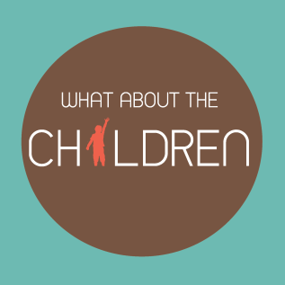
Description:
Established in 2014, What About The Children is an non-profitable organization that represents the children in any war zones. From Asia, Africa, North America, South America, Europe to Australia. Their outreach plans include providing nutritional food, shelter, medicine, sustainable education (leading to further income and jobs) etc.
Mission Statement:
"Provide children, who are confined to conflict areas, with a safe, clean, and inviting environment through sound and equal charity practices. We want to conduct research to enhance productivity and quality of life for children in these harsh conditions and discover newer and more efficient solutions. Through empowerment people we also call for care of the environment and respect for cultural diversity. The organisations funds are reliant upon generous individuals and strong volunteer efforts.”

Our Mandate:
- Social Services at the side of children and their families: Advising and supporting children in difficult living situations
- Advocate of the weak and exclude: Draw attention to the manifold poverty and social injustice to influence socio-political decisions to be made in their interest.
- Builder of Solidarity: Motivate and support persons who get active in parishes and schools, organize concrete help, raise funds and strengthen awareness for social issues.

Principle Values:
- We obligate ourselves in our work to high quality. To assure quality as process method for quality development.
- We avow ourselves to a leadership style that appreciates volunteers, involves them in development and decision processes.
- In the filling of leadership positions we aim for a balanced relationship of women and men.
- In the use of our resources we follow principles of cost effectiveness, frugality and utility.
- Services that we offer have to be regulated by contract and financially secure.
- Donations serve to finance ongoing assistance, quality improving measures and the development of new projects.

